9 February, 2004

To: Ron Hanke, Acting Director, Facilities and Planning

From: Kathleen Heide, Interim Dean, CAS; Chuck Connor, Chair, GLY; Eileen Rodriguez, President Geology Alumni Society; Rick Oches, Interim Chair, ESP; Laurie Walker, Director, Botanical Gardens; Len Vacher, GLY; Mark Stewart, GLY; Mark Rains, GLY.

Subject: Application to formalize the USF GeoPark

The empty space along Magnolia Drive, south of the parking lot south of Hope Lodge and Moffitt Cancer Center and next to the back entrance of Shriners Hospital for Children, has long been used as a site of research, teaching, and alumni outreach by the Department of Geology. The location, which is part of the USF Greenway, is a lovely oasis of Florida-friendly vegetation, within a short walk of the USF Botanical Gardens. It is a geologically significant site, in part because of the occurrence of some classic sinkholes, the study of which has led to deeper understanding of the geological character and hydrological significance of sinkholes in this part of Florida.

Beginning in 2001 when Chuck Connor of the Geology Department and Bob Bretnall, President of the Geology Alumni Society, met with Facilities and Planning, the site has been used for the annual Geology Alumni Society Exposition and has become known in the community as the USF Geology Alumni Society GeoPark. These expositions are essentially on-site demonstrations, and have resulted in the installation of observation wells at the GeoPark that have added to the original array installed many years ago for Departmental research (including two MS theses). The GeoPark is rapidly expanding its potential as an ongoing, on-campus research site.

In association with the awarding of the first Geology Alumni Society Outstanding Alumnus Award (presented at an annual fundraising banquet), the Geology Alumni Society obtained and deposited a six-ton sample of the Floridan aquifer (from the Ocala Limestone), which has been on display at the GeoPark (“The Rock”). Just now, faculty of the Geology Department and the Director of the Botanical Gardens have been awarded a 2004 Community Education Grant in the amount of $5,000 by the Hillsborough River Basin Board of the Southwest Florida Water Management District (SWFWMD). The purpose of this grant is to engage USF students in research and development of interpretive signage to install along mulched pathways through the GeoPark. Titled “USF GeoPark and Botanical Gardens – Linked Resources for Community Education in Hydrogeology,” this grant, we are told, is the first such community-education collaboration by USF and SWFWMD. The GeoPark is obviously becoming a “point-of-light” in USF’s mission of community education.

In view of these growing activities, we request consideration that the USF Geology Alumni Society GeoPark be granted permanent recognition as part of the USF development plan.

For more information about the GeoPark, its history and geology, please see the Department of Geology Website (www.cas.usf.edu/geology), and click on GeoPark from the left-hand column. Below we include more details for your consideration.

Exact location.

The research sinkholes, the wells, and “The Rock” lie nicely in the small area labeled ABCDEFGA in aerial photograph of Figure 1. The northeast boundary corner (A) is the intersection of the turnoff to the Medical Center from Magnolia Dr. The southwest corner (C) is 440 ft south of the drainage canal (along the western part of AB) and 208 ft west of the parking lot at D, which is 120 ft south of the northwest corner of the parking lot (E). The enclosed area is 5.3 acres. At a minimum, we request this area (ABCDEFGA) for the Geology Alumni Society GeoPark.

More expansively, we note that the open space and Florida-friendly vegetation extend through the area to the southwest to the corner (H) of Alumni Drive and Pine Drive (front entrance to Shriners Hospital for Children). This area is indicated by the larger outline AHIJEFGA on Figure 1, and covers 15.8 acres. It also contains sinkholes (most notably an exquisite one labeled “deep sinkhole” in Fig. 1). This larger area, which abuts against the Botanical Gardens, would contain the exposition site in its northeastern corner and be a bridge – eventually with mulched pathways – between the Botanical Gardens and the exposition site. More ambitiously, then, we request this larger area (AHIJEFGA) for the Geology Alumni Society GeoPark.

Alignment with USF Mission

The GeoPark aligns with all four facets of the USF Mission listed on the USF Website: teaching, research, service, and community engagement.

Teaching: The GeoPark is, has been, and will forever be, a teaching resource. It has been used for classroom laboratories in the field by both the Geology Department and the Environmental Science and Policy Department; demonstrations by local environmental geophysical companies; expositions put on by the Geological Alumni Society. With the signage developed with the SWFWMD Community-education grant, the teaching will expand to the broader university community, including visitors to the Botanical Gardens.

Research: Already, the sinkhole at the GeoPark has provided vital insight about the subsurface anatomy of a sinkhole, the structure in the sand mantle above sinkholes, and the significance of sinkholes in the recharge to the Floridan aquifer. With additional wells, and outfitting them with recorders in the future – all of which will happen as we continue along the trajectory that has already been established – the site will continue to contribute insights to the environmental hydrogeology of the covered karst terrain, which Tampa’s urban sprawl is encountering.

Service: Included in USF’s responsibility to the community are discovering and spreading knowledge concerning matters vital to the well being of our citizens. What is more vital than water? Add to that the Florida environment, and interaction of urban development with the geological substrate. These are the educational themes that the GeoPark will bring to the community. At the same time, we hope, the GeoPark will provide a welcome haven within our ever-too-busy campus. Noteworthy, too, is the fact that this quiet, renewing area is available with only a short walk to patients and families at Hope Lodge, Moffitt Cancer Center and Shriners Hospital for Children.

Community engagement: By definition, the Geology Alumni Society and the Community Education Grant from SWFWMD bespeak of community engagement. You might enjoy visiting the GeoPark web page and noting the response of the community to the APB put out by the Geology Department to show up one cold December Saturday morning to help mulch some pathways. As it has become known that we are developing signage for the outdoor educational facility, volunteers have joined our task force from the U.S. Geology Survey, the Department of Environmental Protection, and SWFWMD, and we haven’t yet begun to ask for input.

Scope of Work

The community-education grant from SWFWMD to develop the GeoPark into a community-education facility is administered with a purchase order that reads as follows:

This project will educate approximately 1,000 USF GeoPark and Botanical Gardens visitors on sinkholes, the hydrologic system, stormwater runoff, and Florida-friendly vegetation and its relation to the hydrology. Education will be accomplished through signage, brochures, fliers and kiosks located at the GeoPark and the Botanical Gardens. In addition, educational workshops and self-guided tours will be conducted at these sites. All materials and products resulting from this grant will acknowledge the Hillsborough River Basin Board of the Southwest Florida Water Management District and are subject to review and approval by the District’s Project manager. Funds are released on a reimbursement basis only. Final report due July 30, 2004.

The signage referred to in the purchase order will be mostly at the GeoPark (we anticipate 4-6 signs, depending on cost). The kiosks with the brochures (including a self-guided tour looping over to the GeoPark), and one sign, will be at the Botanical Gardens. We anticipate that the signs will be ~ 3 ft by ~4 ft, inclined low to the ground, fiberglass, like signs at National Parks. For more details, including the subjects of the signage, please see the attached proposal that was submitted to SWFWMD.

Two signs might be of particular interest to USF Administration: (1) Concerning the stormwater drainage ditch along the north side of the GeoPark – Stormwater drainage in a karst (sinkhole-ridden) terrain is of great interest and relevance to water management in this part of Florida, and so the sign will explain the geological and hydrological reasons for policies about such things, and how USF complies with them; (2) Concerning the hydrologic community – USF is one of several places with educational exhibits developed under the SWFWMD Community Education program, and so one sign will include a map of the Hillsborough River Basin with arrows pointing out other water- and environment-related displays (e.g., Lettuce Lake Park; the Florida Aquarium; Hillsborough River State Park). Both of these signs underscore how the GeoPark can promote USF’s role as an environmental leader in our community.

Impact on Campus Master Plan

The GeoPark takes the best piece of the Master Plan and makes it better. How many urban universities have a Greenway (Fig. 2) that goes from one end of the campus to the other? The Greenway enhances the University in the same way that the National Mall enhances Washington DC. It is something that USF can be proud of. The GeoPark will add tasteful, educational signage, near the southwest anchor of the Greenway. In a quiet, modest way, the GeoPark will add an outdoor museum element to it.

Appropriateness of the Players

USF Geology Department is becoming a leader nationally in the study of karst – the geological term for regions underlain by partially dissolved limestone and marked by sinkholes, fabulously productive aquifers, and springs. Because of the long history of hydrogeological education at USF, alumni of the USF Geology Department dominate the groundwater and environmental-geology profession of Florida, including SWFWMD and other agencies with water responsibilities. The Geology Alumni Society routinely wins the annual award from the USF Alumni Association for the outstanding alumni society. Bob Bretnall, mentioned early in this document as one of the originators of the GeoPark concept, received the Gifford Award of the USF Alumni Association; he was honored at half-time of the last Homecoming game.

The GeoPark thus represents a blending of strengths – a magnificent concept in the Master Plan (the Greenway); an outstanding Alumni group; an area of national scientific expertise – and pulls them together for the benefit of community education right here on our campus. Moreover, everyone needs a quiet park, with big oaks and open space.

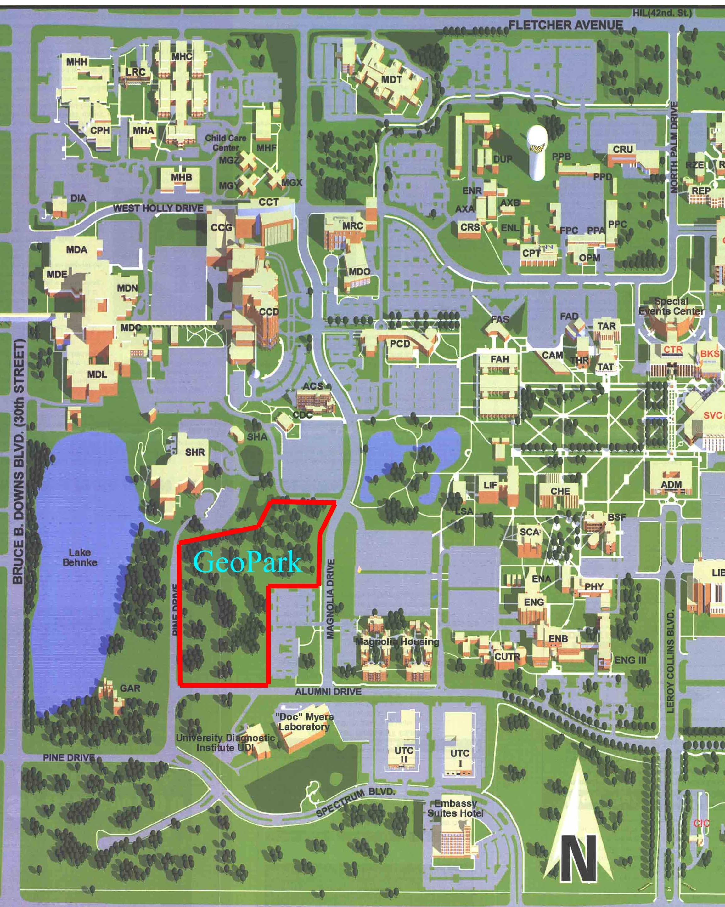

APPENDIX

PROPOSAL SUBMITTED TO SWFWMD.

Southwest Florida Water Management District
2004 Community Education Grant Program Application

Project Name: USF GEOPARK AND BOTANICAL GARDENS – LINKED RESOURCES FOR COMMUNITY EDUCATION IN HYDROGEOLOGY

Organization University of South Florida:

Federal I.D. Number or Social Security Number:

Contact Person: H.L. Vacher and Mark Stewart

Address: Department of Geology, SCA, University of South Florida
City, County, ZIP: Tampa FL 2262
Phone: 974-5267 (Vacher); 974-8749 (Stewart); 974-2236 (main office)
Fax: 813-974-2654
E-mail: vacher@chuma1.cas.usf.edu mark@chuma.cas.usf.edu

Total Amount Requested (not to exceed $5,000): $5,000.00

Community Your Project Will Reach: Students and visitors to USF Tampa campus and the USF Botanical Gardens.

Number of Persons Project Will Reach (estimate): 1000+

Project Beginning and Completion Dates: March 1 – June 30, 2004
(Project implementation period is from March 1 through June 30, 2004.)

Answer the following questions clearly and completely using only the space provided. Return completed applications no later than October 17, 2003, to any of the District service offices listed at the end of the application.

1. If my proposal is funded, it will provide my community with education about (check one or more categories):
___________ Alternative water sources
__partly___ Water quality
__partly___ Water conservation
___________ Flood protection
__mostly___ Natural systems, watersheds or ecosystems

2. Describe in 150 words or less the specific water-related concern(s) your proposal is designed to address:

The USF Geology Alumni Society GeoPark, located on the main campus of USF, sits atop a magnificent and uniquely well-studied sinkhole. The studies have documented the subsurface anatomy of the sinkhole and have established that it is a recharge site for the Floridan aquifer. Similarly, Lake Benke at the Botanical Gardens, a short walk away, is a recharge site encompassing sinkholes. In fact, it is a site of enhanced recharge, a retention pond receiving stormwater from that part of campus to the lake.

The multi-acre GeoPark is located in a natural wooded area, part of the University’s greenbelt, with live oaks, turkey oaks and saw palmetto. A five-ton sample of the Ocala Limestone, selected by Tom Scott (Assistant State Geologist and USF Alumnus) from a quarry in Marion County, is a prominent feature of the park.
With this application, we propose to install educational signage along mulched walkways and next to “The Rock”, and in the Botanical Gardens, to educate visitors of the hydrogeology and environmental context of this location. We intend for this site, with its connection to the Botanical Gardens, to be a resource for both university courses and community education.

3. Describe in 100 words or less why you and/or your organization will be successful at implementing your proposal.

We represent a committee comprising groundwater professionals, and the Director of the Botanical Gardens, a specialist in native plants and plant conservation. Len Vacher, Mark Stewart, and Mark Rains are USF hydrogeology faculty. Also included are SWFWMD geologists, John Parker (who mapped the subsurface configuration of the sinkhole for his MS thesis with Mark Stewart) and Dave DeWitt (active in getting “The Rock” to the GeoPark). The non-USF geologists represent the Geology Alumni Society, which is prominent in the professional geological community. We have the expertise, as well as interest in both education and SWFWMD’s mission.

4. Who will participate in the learning activities that are a part of your project? Please be specific and include estimated numbers and the geographic area targeted, i.e., 150 homeowners in XYZ community.

The active-learning activities will be preparing the information for the interpretive signs and brochures. This will be done by seven graduate students of the Karst Research Group and students who will enroll in two graduate courses in Spring semester (karst geology [HLV et al.] and ecohydrology [Rains]). Geology and non-degree seeking students enrolled in these courses (approximately 20) will produce the text and drawings for the signs and brochures as team projects. One or more of the teams of graduate students will lead a community-outreach field trip on the geological, hydrogeological, and ecological material in the signage as one of the workshops in the Saturday morning series at the Botanical Gardens. These workshops are routinely well attended by both BG members and non members.
The passive-learning activities involve informal education in the way of brochures and interpretive signage at the GeoPark and the Botanical Gardens. Located adjacent to the Shriners Hospital for Children, the American Cancer Society’s Hope Lodge, and near the Moffitt Cancer Center and Magnolia Apartments (graduate student housing), the GeoPark is accessible to thousands of visitors on a daily basis. It is the site of the annual Geological Society Expo, which is attended by a couple hundred people from the community of environmental professionals in the SWFWMD area. In addition, more than 30,000 people visit the Botanical Gardens every year (from 17 countries, 2 US territories, 37 states and 87 Florida cities). Biology, botany, ecology and environmental sciences classes from USF, the University of Tampa, St. Leo College, Hillsborough Community College and local public and private schools visit the Gardens throughout the school year. Local garden clubs and circles and Master Gardener groups from as far away as Hernando and Highlands counties tour the Gardens. The Gardens semi-annual plant festivals bring ~5,000 people to the Gardens for each event. Overflow parking for these special events is among the trees on the southwestern edge of the GeoPark. With the signage at the Botanical Gardens and the linkage of the two sites, we expect hundreds, perhaps even a thousand, of Botanical Gardens visitors to venture over to the sinkhole and rock.
In addition to this active/passive breakdown, there is another somewhat intermediate group that will participate – students in geology classes that will use the GeoPark for lab and field exercises. Presently there are about three of these courses, with perhaps a total of 30 students per year.

5. What will people who participate in your project learn?

What a sinkhole looks like. The underground anatomy of a sinkhole. The porosity and general look of the rock composing the Floridan aquifer. The concept of a hydrologic system, from sinkholes to the Floridan aquifer. The concept that what goes in goes somewhere. The concept of Florida-friendly vegetation. The location of other environmental-educational exhibits in the Hillsborough Basin.

6. As a result of the learning experience you will offer, how will the water-related concern(s) in your community be improved?

Active participants: By giving graduate students experience in writing for the lay public about technical water-related subjects. Passive participants: By sensitizing the lay public to the concept that hydrologic systems are all around them, even here on campus.

7. What materials will you use to provide the people participating in your project with a learning experience?

We plan five major custom-made fiberglass information signs at the GeoPark: (1) looking at the sinkhole from a vantage point along a walkway – description and drawings of the geology and plumbing of a recharge sinkhole, and its relation to surrounding groundwater; (2) at “The Rock” – description and drawings of the Floridan aquifer; (3) looking at the grove of Florida-friendly vegetation – description and drawings of the vegetative ecosystem and its relation to the hydrology; (4) in the vicinity of drainage canal at the north end of the GeoPark – description and drawings of how runoff from campus is conveyed to the pond at the Botanical Gardens; the place of stormwater in the groundwater budget; and (5) at some strategic and comfortable site along a walkway -- overall comments on the quantity and quality of water resources, the concept of the Hillsborough Basin, and a guide to other outdoor educational resources in the Hillsborough Basin. At the Botanical Gardens, we plan one major information sign at the pond, discussing its role in the hydrologic system, and making the point about human impact on sinkhole-related recharge sites of this part of SWFWMD. Also at the Botanical Gardens, we will have a brochure kisok, with brochures including a self-guided tour including the GeoPark. In addition, we plan smaller signs identifying various plants and other points of interest along the mulched walkways.

8. What activities will participants in your project complete?

The active participants, the students preparing the information for the signs, will pull together information from SWFWMD documents and USF theses, consider how to communicate the material to a lay community, and prepare the text and figures for fabrication by the sign-making company. The passive participants, the visitors to the site, will complete pleasant and informative strolls. They will learn from the interpretive signage and brochures during the self-guided tours. Members of the public attending the workshop at the Botanical Gardens, will learn from the graduate students, who themselves will learn by teaching.

9. In what ways will people learn of the opportunity to participate in your project?

Active participants (karst and ecohydrology classes): on the course syllabus.
Passive participants (visitors): brochures in information kiosks at the Botanical Gardens and word of mouth from USF students, members of the Geology Alumni Society and people at SWFWMD Flyers at the BG Spring Plant Festival in April?

10. Is your project part of an ongoing project? _x__Yes ___ No

USF plans a greenway from the west side of campus to the east side, passing though the Martin Luther King Plaza to the northeast corner of campus at Fletcher Avenue. The Botanical Gardens is the west-end anchor. This project will link the Botanical Garden and GeoPark and constitute the second step in building an on-campus hydrogeology research site. The first step was the prior scientific work by Parker and Stewart, and bringing in the rock. Already, the site is used for lab/field exercises in at least three courses. Future steps will involve installing additional wells and instrumenting them, both for educational and sinkhole-research purposes.
In addition, we anticipate that in time the GeoPark will become networked to a larger constituency. We will develop links with the Department of Education (e.g., pre-service teachers) and MOSI.

- Is the District already involved in the project in some way?
__x_ Yes ___ No

The GeoPark exists because of the initiative of the USF Geology Alumni Society, many of whom are SWFWMD people. The GeoPark has been the site of the last two Geology Alumni Society Expositions, one of the major contributors to which has been the SWFWMD. “The Rock” was intended by the Geology Alumni Society to be the centerpiece of the GeoPark, and a SWFWMD person was in the small group of alumni that made it happen (together with Tom Scott of the Florida Geological Survey). Moreover, the GeoPark is only one manifestation of the collaboration between the Department and the Geology Alumni Society, and SWFWMD has been a main supporter of that collaboration (e.g., the Geology Alumni Society hosts the Internship Project Presentations dinner, and the venue is the Tampa office of SWFWMD)

If yes, please list District staff with whom you are or have been working.

Gregg Jones was on the original Board of Directors of the Geology Alumni Society. Dave DeWitt, who is on the present board, was a major player in getting “The Rock,” and is the organizer of the Geology Alumni Society Internship Project presentation evenings at SWFWMD. John Parker and Dave DeWitt are members of the committee that will oversee this project.

12. How will you measure what people participating in your project learned? Please be specific.

Geology students, who do the research for the information signs as part of their coursework – we will assess the outcomes (i.e., the signs, brochures, workshops, tours, as well as exams. For the non-student visitors, we will have tear-off, send-in surveys on the brochures. For the participants in the workshop at the Botanical Gardens, we will include user surveys and/or evaluations

13. How will you acknowledge District support of your project?

The District will be acknowledged on signage, in brochures and all print material and on relevant websites (Botanical Gardens, Geology Department, Geology Alumni Society)

14. How much funding are you asking the District to provide (not to exceed $5,000)? $____$5,000_____

Please attach a separate sheet with a line-item budget to detail your expenses,

Please see attached

15. Have you received, applied for, or expect to apply for funding for this project from sources other than the Southwest Florida Water Management District? ____ Yes __x__ No
If yes, please explain:

16. How is your association, organization or group funded?

USF is a state university. The Geology Alumni Society is a dues-supported organization. Its events and projects have to pay for themselves.

17. Have you, your association or group received a Community Education Grant before?
____ Yes __x__ No
If yes, what year? _______ Was it completed on time? ____ Yes ____ No

If the Applicant is awarded any funds under this program, the Applicant agrees to indemnify, save and hold harmless the Southwest Florida Water Management District (District) from any obligations, costs, claims, judgments, attorney's fees, property damage or personal injury or death resulting from or arising out of any act or omission of the Applicant in relation to its participation in the Community Education Grant Program. Applicant acknowledges that it will perform the proposed project as an independent contractor and that it is not an employee or agent of the District and agrees that all materials and activities resulting from this Community Education Grant Program will recognize District and Basin funding in the form of signage, logos and/or language as prescribed by the District. Approved projects may be asked to provide insurance coverage or other financial risk protection at no cost to the District if such coverage/protection is deemed necessary by the District's risk management staff and/or legal representation.

Name of Individual or Sponsoring Group:

Authorized Signature: ________________________________________ (must be handwritten)

Date:

Unsigned applications will not be reviewed for consideration.

Mail or deliver your application by October 17, 2004, to any of the addresses below. Delivered applications must be received by 5 p.m. and mailed applications must be postmarked by 5 p.m.

Community Education Grant Program
District Headquarters
2379 Broad St.
Brooksville, FL 34604-6899

Community Education Grant Program
Bartow Service Office
170 Century Blvd.
Bartow, FL 33830

Community Education Grant Program
Lecanto Service Office
3600 West Sovereign Path
Lecanto, FL 34461-8070

Community Education Grant Program
Tampa Service Office
7601 U.S. Highway 301 North
Tampa, FL 33637

Community Education Grant Program
Sarasota Service Office
6750 Fruitville Road
Sarasota, FL 34240-97113

BUDGET

Direct Costs

Custom-made, fiberglass information signs
6 @ $700 each $4,200.00
Brochures and brochure stand 561.00

Total Direct costs $4,761.90

Indirect costs (5% of direct costs) 238.10

TOTAL $5,000.00

