
Travel Department
Designate Alternate User in Workflow

Purpose: | To temporarily designate alternate user in FAST to approve Travel transactions.
Navigation | Navigation: FAST Home Page > Navigator > My System Profile
Notes: | Note that this process should be used for only temporary designation of alternate users (less than six months) such as in cases where the employee is on business travel, annual leave or medical leave.  Any long-term delegation of authority to approve transactions should be submitted via the ‘Temporary Workflow Reassignment’ form and needs to be approved by the area VP and University Controller. The completed form should be sent to travelhelp@usf.edu . Travel department will request the University Controller approval.

Steps to Designate Alternate User:
Steps | Description
1 | Enter the Alternate User’s FAST ID. (Ensure with the Alternate User that they have the Approval role in FAST Travel Module)  If you do not know the FAST ID, you can use the Advanced Lookup option:  1.) Click on the magnifying glass at the end of the field, this should open the "Look up Alternate User ID" page  2.) Then click on the hyperlink that's named "Advanced Lookup"  3.) Then choose "contains" from the drop down for the 'Description' field  4.) Then you can type any part of the User’s name and this should pull up FAST IDs that match what was typed in  5.) Click on your selection- it will return to the previous page  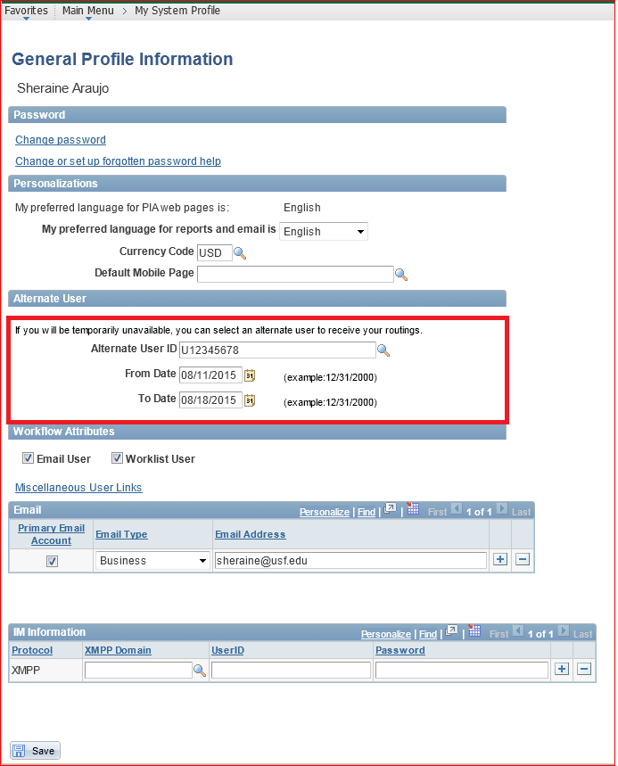
2 | Enter the first day that travel transactions should route to a different user.
3 | Enter the last day that travel transactions should route to a different user.
4 | Click the “Save” button at the bottom of the page.

