Purpose: | Travel documents must be signed by the traveler certifying and affirming to the expenses for a business trip. Travelers can also sign electronically using secure mobile app DocuSign or Adobe Acrobat Pro.
Notes: | Travelers should use only acceptable digital signatures. USF has a site license for DocuSign and electronic signatures using this product are secure and legal. Travelers opting for Adobe authenticated method will need to have Adobe Acrobat Pro Installed on their computer.

DocuSign for Electronic Signatures:
Description
How to sign in to DocuSign for USF

- Visit http://docusign.com
- Click on LOG IN in upper right corner
- Click on COMPANY LOGIN
- Enter your Email Address and click CONTINUE
- You will be redirected to USF NetID Single Sign On for authentication
- Enter your NetID and Password and click Sign In

Description
How to use Docusign.com

Get started quickly by utilizing the online training information provided by DocuSign.

Support videos - Learning the Basics: https://support.docusign.com/en/learningTheBasics
Support home: https://support.docusign.com/en/home
New user guide: https://support.docusign.com/en/guides/ndse-user-guide
How to sign in: https://support.docusign.com/en/articles/How-do-I-log-in-to-and-access-my-DocuSign-account
How to send a document: https://support.docusign.com/en/videos/New-DocuSign-Experience-Sending-Documents
How to sign a document: https://support.docusign.com/en/articles/How-do-I-get-signatures-on-a-document-New-DocuSign-Experience
How to manage documents: https://support.docusign.com/en/guides/ndse-user-guide-managing-documents
How to download or print your document: https://support.docusign.com/en/guides/ndse-user-guide-download-or-print-your-document

Adobe Digital Signatures
Description
Save the document as a PDF File

Open the file. Click on Tools. If you have not created your digital signature, click on ‘sign Document ‘ and follow the steps to create the signature .
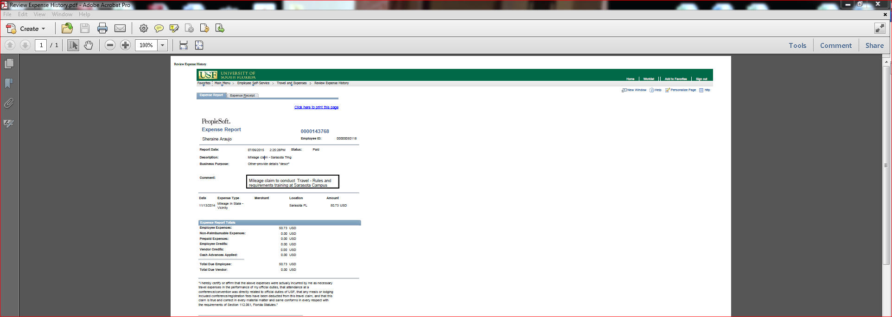
Once the signature is created, select ‘Place Signature’ under tools. Click and drag to draw at the area where you would like the signature appear. The following is how it will look.
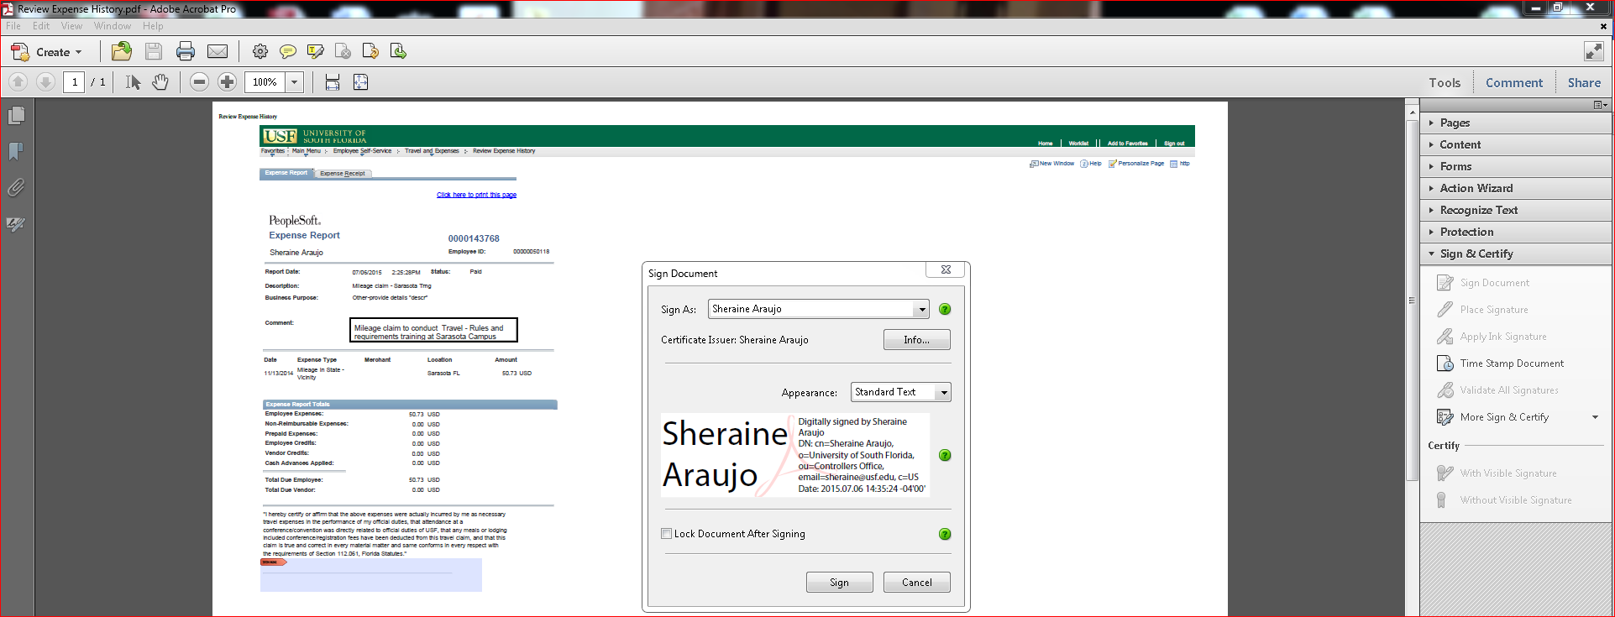
Click Sign. It will prompt you to save the document. Save it and forward to your Travel Submitter to include in the receipts package and submit to travelreceipts@usf.edu.

Unacceptable Digital / Electronic Signatures
Description
Examples of unacceptable digital signatures are below. Please note that cutting and pasting signatures from another signed document is fraudulent.
 Using Script Font
Cutting and Pasting from Another Signed Document

