Getting to Know the Finance Mart

- Certified Departmental Financial Statements……………………………….….2

- Navigation……………………………………………………………………….…………….3

- Report Building…………….……………………………………………………….……….5

- Navigation Tips………………………………………………………………………………9

- Report Samples…………………………………………………..……………………..….20

- Contact Information..……………………………………………..……………………..24



Certified Departmental Financial Information

The official departmental financial information is published daily in the Finance Mart. These are considered the official reports because they are reconciled to the FAST general ledger monthly. No special security access is needed to view the reports; all reports are available on demand and are refreshed daily. All you need to do is open up the web site and select the reports you want to view. You may view them on screen, print them, or download them to an Excel spreadsheet

In addition, when each fiscal period (month) is closed, you will see a message appear indicating that the month has been closed. At that point, the reporting for that period is final.

The Finance Mart reports are static and may not be changed. They are designed to report all funding sources and all departments. Standard business reports are available including RSA (budget), Financial Summary Report (revenue and expense), Balance Sheet, and Encumbrance Report. These are offered in both summary and detail format. The data displayed in these reports will always be as of the day before.

The purpose of this tool is to support your reconciliation effort and to provide information for best management of your funds. Use this tool for reporting on state funding, grant funding, auxiliary funds, agency funds, and any other USF funding that you have.

To provide better performance and quicker report building, Finance Mart includes financial data for only the current year and the prior five years. At the beginning of each fiscal year, the oldest year data will be archived.

Navigation To Finance Mart

Navigation for USF employees is simple and does not require a Logon ID or a password. No special software is needed.

- Navigate to www.my.usf.edu
- Log in with your USF NetID and password

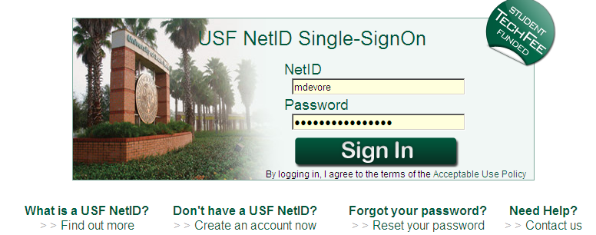

- You should see a welcome page very similar to this.

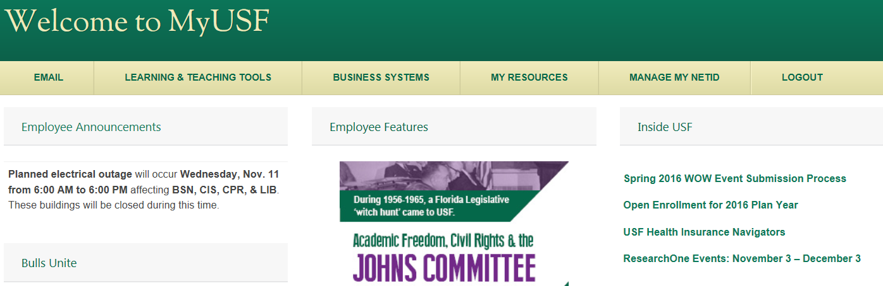

- Click Business Systems
- Click Data Marts
- Then click

- A new screen will appear offering the option to build selection criteria; the screen should look like this

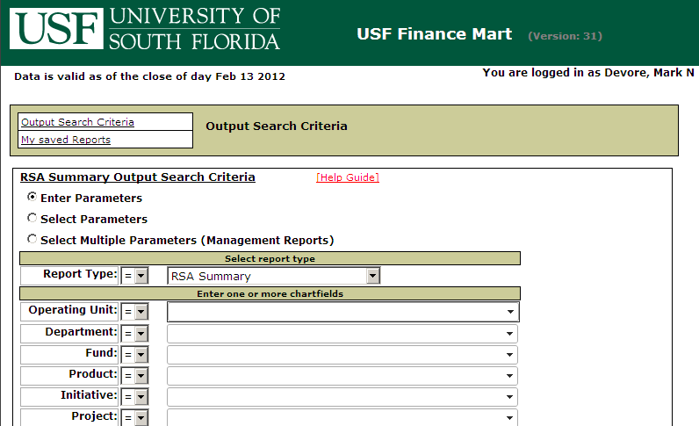

- You are now ready to begin building your reports

- Student employees have access to Finance Mart using their NetID

- Use this url if you are accessing through the USF portal
- https://mysites.usf.edu/default.aspx

- Or use this url for direct access or if you are accessing from home via VPN
- http://usfweb3.usf.edu/freports/

Report Building

There are three primary components for report building

The specific report desired

The chart field(s) that you wish to report on

The period of time that you wish reported

Reports Available from Finance Mart

RSA (Remaining Spending Authority) Summary
A comprehensive report that includes budget released, encumbrances (requisitions and purchase orders), travel expense reports currently in Travel Audit, actual expenditure paid to vendors, and RSA.

Financial Report Summary
Reports revenue and expenditure grouped at the account code level.

Balance Sheet Summary
Reports balance sheet components summarized at the fund or project ID level. Balance sheets report all assets, all liabilities, and fund balance (also called equity).

Encumbrance Summary
Reports encumbrances (PO”s) and travel authorization requests (TARs) for a selected chart field.

Payroll Detail
Reports all payroll by employee at the detail level (individual transactions).

Expense Detail
Reports all expenditure in detail (individual transactions).

Revenue Detail
Reports all revenue in detail (individual transactions).

Budget Detail
Reports all budget allocations at the detail level. (individual transactions).

Balance Sheet Detail
Reports detail transactions of the balance sheet components at the fund or project level. Balance sheets report all assets, all liabilities, and fund balance (also called equity). On a Balance Sheet, for a closed accounting period, total assets always equal the sum of total liabilities and fund balance.

Encumbrance Detail
Reports detail transactions for selected encumbrances (PO’s) and travel authorization requests (TARs)

The encumbrance amount in RSA Summary and Financial Report Summary is the sum of both pre-encumbrance (requisitions) and encumbrance (purchase orders) amounts.

The encumbrance amount in Encumbrance Summary and Encumbrance Detail is the encumbrance (purchase order) amount only.

Chart Field Selection for Non-grant Reports

Reports may be built on the following chart fields

Operating Unit
Department
Fund ID
Product
Initiative

Often it is best to use minimal chart field values. By using a very broad search you will reduce the risk of excluding results. For example, imagine that a transaction is created but the wrong Operating Unit is used by error. If you search by Fund ID and Operating Unit, your results will not include the transaction that carries the wrong Operating Unit. If, however, you search only by the Fund ID, all transactions will be displayed, even the transaction with the wrong Operating Unit.

But there are occasions when you need only very specific data. You may need only a limited amount of information returned. To limit the search, select chart field values to the lowest level (Product or Initiative).

Chart Field Selection for Sponsored Research Project Reports

Before building the report, if the project includes cost sharing, consider whether you want a consolidated report of the grant and the cost share, or just the grant, or just the cost share transactions.

Sponsored research projects run on fiscal years that often are not the same as the USF fiscal year. Sponsored research projects operate and are reported on a LTD (Life to Date) basis. A report run that includes both the grant and the cost share will report on an LTD basis even if the cost share portion is from a fund source that normally reports on YTD (Year to Date) basis.

For example, to run an RSA Summary for project 1230107500 which does include cost share paid from fund 10000, create the search as below.

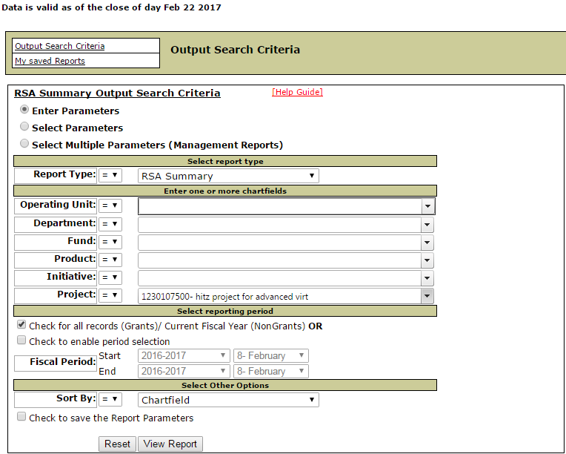

This search will result in an RSA Summary displaying the cost share transactions from fund 10000 and grant transactions from the research fund 22000 and related F&A postings. Transactions for each unique chart field string will appear with sub-totals with a grand total of transactions for all fund sources at the end of the report.

Period of Time

These reports are offered with two options. The default time frame is:

Fiscal year to date for non-grant reporting
Life to date for grant reporting

As an alternative, you may specify a period of time, either one month or a period of several months. This option is very helpful with transaction reconciliation.

Summary - Required Steps To Build A Report

- Select a report type from the drop down menu (ten choices)

- Identify the desired chart field values in one of three ways; 1) the default of Enter Parameters, 2) Select Parameters, or 3) Select Multiple Parameters

- Accept the default Life To Date/Year To Date condition or specify a time period

- Click

- Check the create a refreshed version of frequently run reports

- The following example illustrates setting up a balance sheet summary report for fund 18570 for the current fiscal year-to-date.

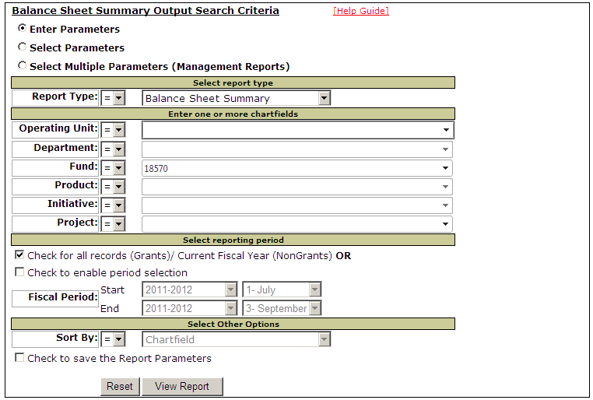

Important Navigation Tips

The following are tips that you should find useful when building and reading reports.

Tip 1 – Saved Reports

Click this in the upper left side of the Output Search Criteria page to review reports you have already created. The reports that you create are automatically saved to this library. Click the button to view the desired report; it will be an updated current report, defaulting to the RSA Summary.

Sample of My Saved Reports

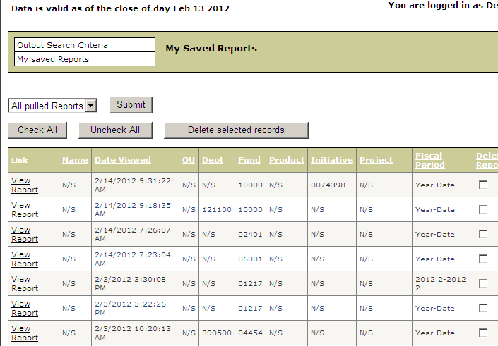

Also remember that you can delete reports that you no longer want or need from the Saved Reports list. Just check the “Delete Reports” box (far right column) for the specific reports and complete the action by clicking the “Delete selected reports” button near the top of the page.

Tip 2 – Chart Field Selection

You may select the chart fields for your report by one of three methods, Enter Parameters, Select parameters, or Select Multiple Parameters.

The Enter Parameters option (system default condition) allows you to directly enter the value of the chart field. As you enter characters in the chart field value fields, a prompt will appear with options to choose. For instance, Fund ID’s are five digits long. As you type in the digits of the fund ID, a list will appear filtering as you continue typing. You may choose from the list or continue typing in all five values. See the image below.

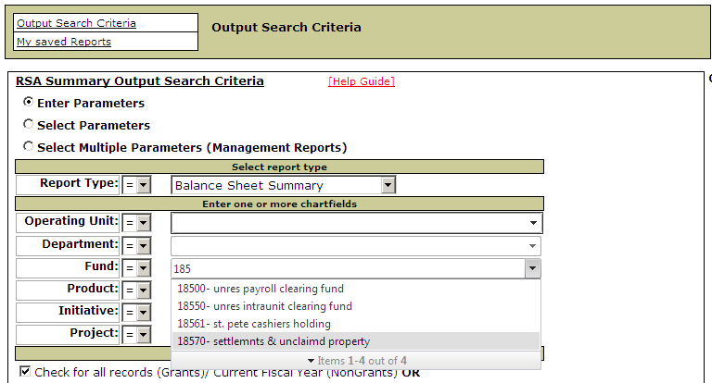

This feature may be used for any of the chart field values (Operating Unit, Department, Fund, Product, Initiative, or Project).

The Select Multiple Parameters option allows for building reports for multiple chart fields. You might need a report combining two or more departments or two or more funds. This option will produce a report of all requested chart field values with individual sub-totals and a grand total of all chart fields requested.

First click the “Select Multiple Parameters” button. Then to select a series of chart fields (fund for example), click the first fund ID desired, hold down the “Shift” key and use the down arrow to highlight the rest of the desired fund ID’s. The setup page for an RSA report to include six funds would look like this:

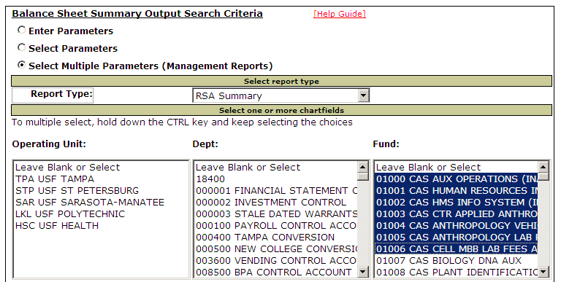

Use this method to report multiple operating units, departments, funds, products, initiatives, or projects.

If the desired chart field values are not in a sequence, you may opt to select specific chart fields. Hold down the “Control” key and click the desired chart field values. For example:

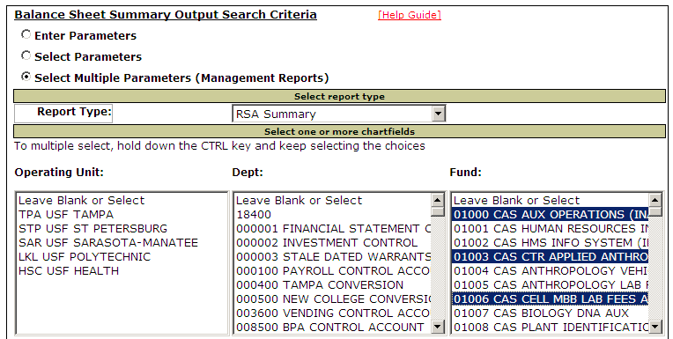

Tip 3 – Reporting for One Specific Month

You may build a report for a specific period of time by checking the “Check to enable period selection” box. Then indicate the months desired; in the illustration below the month of July has been selected. Remember that you should not cross fiscal years when using this method of building a report except for grants or projects. Also remember that 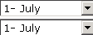 does not mean July 1. It refers to July, which is period 1 of the fiscal year.

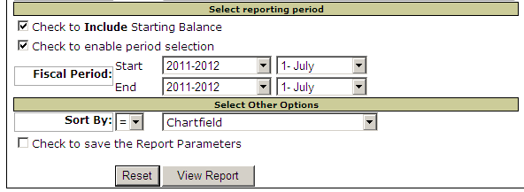

Building a report for one specific month is especially helpful when reconciling monthly financial activity.

Tip 4 – Reporting YTD or LTD

Instead of selecting a specific time frame, you may choose to build a Year-To- Date report for state funds or auxiliary funds or a Life-To-Date report for grant funds. Note: when the default condition “Check for All Records (grants)/Current Fiscal Year (non-grants) selection has been made, the fiscal period fields are not open.

If you want to see all life to date transactions on a project without having to drill down, select “Check to enable period selection” and then pick as a start date the actual starting point for the project and an end date to suit your needs. The Expense Detail report will show all transactions (at a transaction level) for the entire life of the project. The transactions appear in budget account order with the related general ledger accounts.

Tip 5 – Viewing and Downloading

To view the report output on full screen, click the button in the upper left corner of the screen. You may also download the report to an Excel spreadsheet, a web friendly report, or a pdf format.

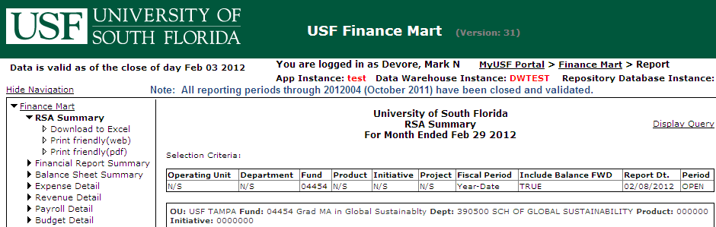

Tip 6 – Drilldown to Budget Detail

When viewing the RSA Summary report, you may drill to detail by clicking the budget account number in the far left column (notice it is underlined).

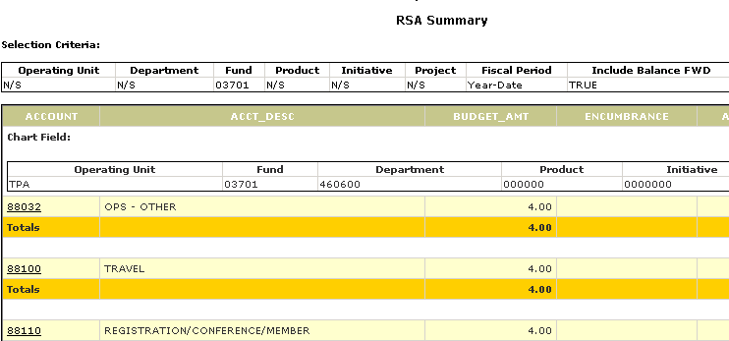

After clicking the budget account number, the details of transactions for that account number will appear. For this illustration, the user clicked 88032 resulting in the following display. After reviewing the detail report, you may return to the RSA Summary Report by clicking the RSA Summary option on the menu.

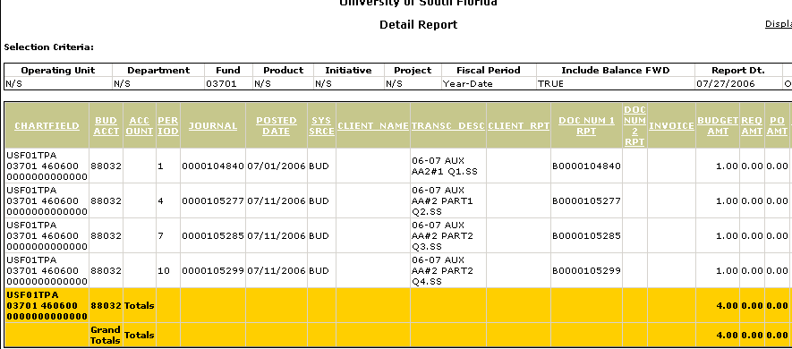

Tip 7 – Drilldown to Expense Detail

When viewing the Expense Detail report, you may exclude beginning balances to view only current year detail. This is helpful for reconciliation to view only the detail transactions for a specific period. To do this, run the Expense Detail report, then click the “Show Detail” box on the right side of the screen. A report of all transactions will appear. An additional option is to click the “Drilldown” link in the Period column.

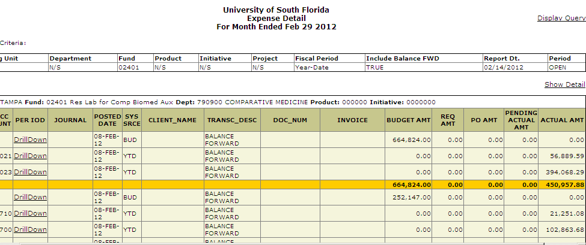

The resulting report will appear as:

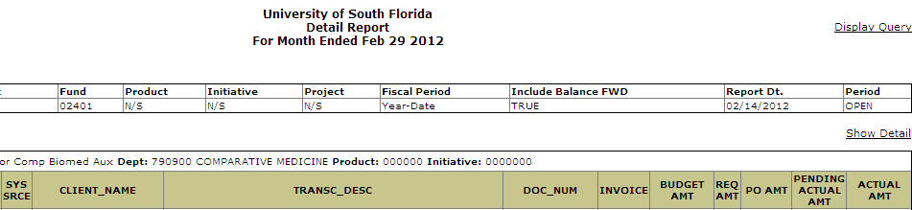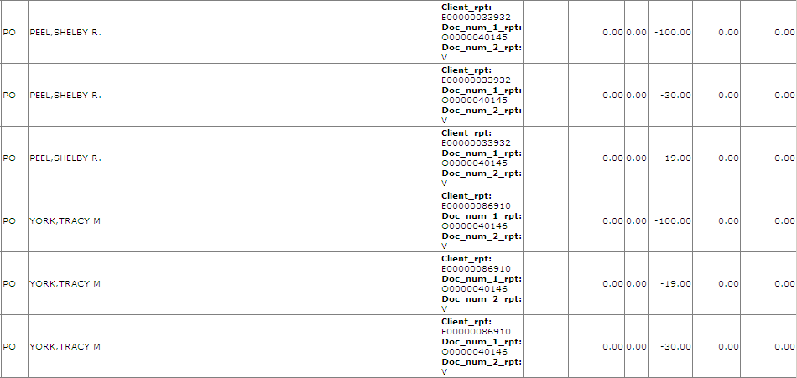

Tip 8 – Open and Closed Periods

Notice that the period is described as either “open” or “closed”. An open period means the month has not been officially closed in FAST. The report becomes static when the month is officially closed and no more transactions can be posted. This becomes very important when running a Balance Sheet report.

A search range that includes both open and closed periods will display as open.
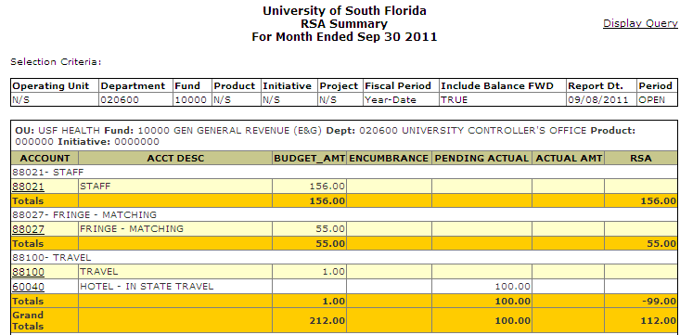

Tip 9 – Viewing Another Report for The Same Chart Field(s)

After viewing a report, if you want to view a different report with the same chart field(s), you may simply select a different report with one click.

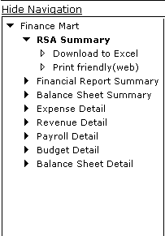

Tip 10 – The Reset Button

After you have produced a report, if you wish to build another report with different chart fields, it is recommended that you click the button. This will clear the chart field values to ensure that you build a valid report.

Tip 11 – Building A Report for A Different Chart Field

To build a new report for a different chart field(s), click the Finance Mart menu option, click the button at the bottom left corner of the page, and then build the new report.

Tip 12 – Special Note at Top of Page

Notice the message at the top of the page. It will indicate the most recent period that has been closed and validated.

Tip 13 – Pending Actual Column

The RSA (Remaining Spending Authority) report displays released budget, encumbrances, pending expenses, actual expenses, and RSA. The pending actual column includes travel expenses from Travel Expense Reimbursement requests that have been submitted to travel audit but not yet paid to the vendors. Since these pending expenses represent a potential reduction in RSA, they are displayed in a separate column.

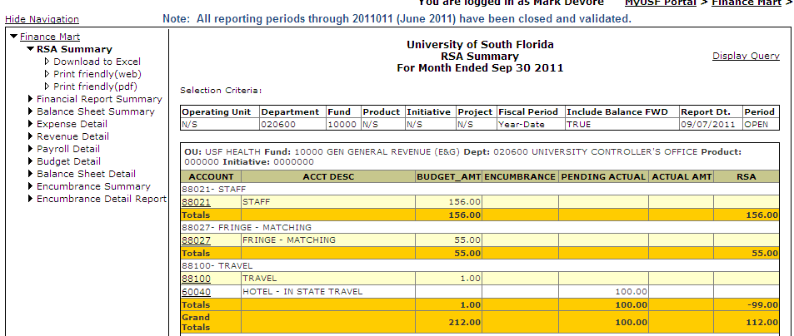

Tip 14 – The Journal Column

The “Journal” column identifies the journal ID which contains the accounting lines. Remember that journal IDs typically begin with a three letter mask that describes the type of entry. For refresher of the definitions of journals masks, on the USF Controller’s web site (www.usf.edu/business-finance/controller) look under Accounting and Reporting/Forms/Journal Entry Mask List.

Tip 15 – The Reference Columns

Two of the columns on the expense detail report include references that will help you search for additional detail in the originating business systems (GEMS, OASIS, and FAST).

The “Client_Name” column will display the actual client or vendor ID. The prefix (below) will identify the type of client and lead you to the originating system.

M Pcard merchant related to an Accounts Payable transaction
S Supplier (vendor) in a FAST Accounts Payable transaction
C Customer ID from a FAST Billing/AR transaction
E Employee ID from GEMS records

The references appearing in either of the two “DOC_NUM” columns will begin with a prefix describing the type of document/action.

B Budget journal
D Deposit number (AR module)
I Customer Invoice number (Billing module)
J From the Actuals journal (General Ledger)
K Check number (USF check number)
O Purchase Order numbers and travel authorization numbers
Q Requisition number
R Receipt number (OASIS receipt number)
T Time stamp number
V Voucher number (Accounts Payable module)
X Travel expense report number

Report Samples

Sample RSA Summary Report page

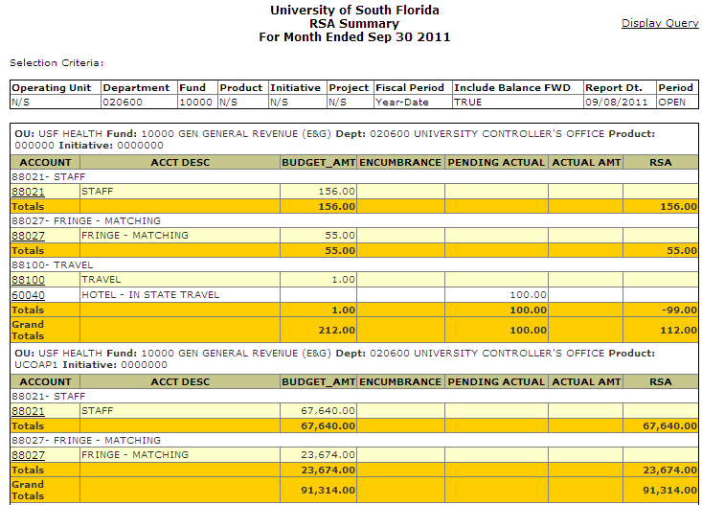

Sample Budget Detail Report page

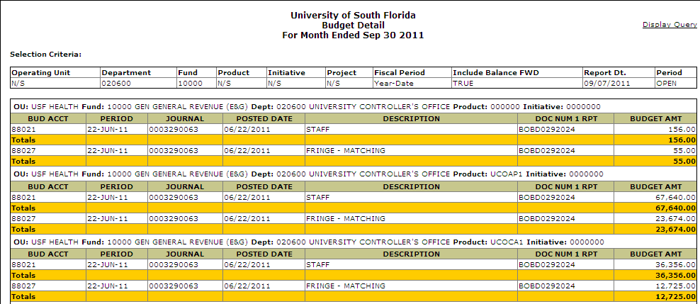

Sample Financial Report Summary page

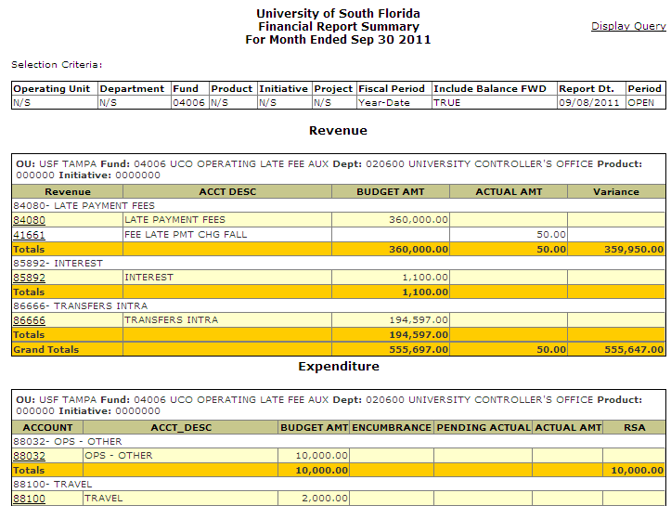

Sample Revenue Detail Report page

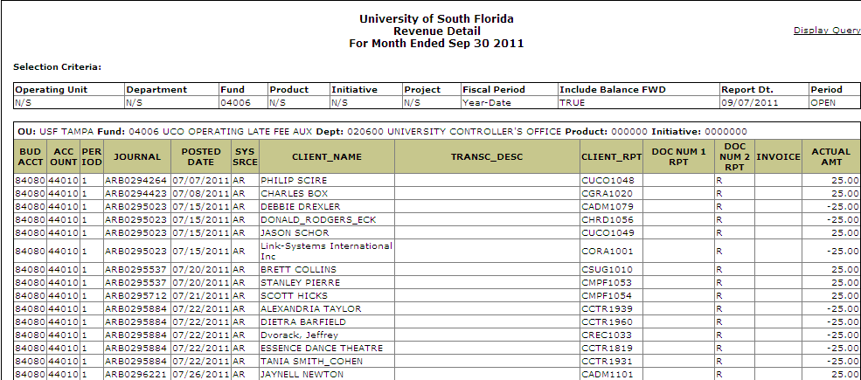

Sample Expense Detail Report page

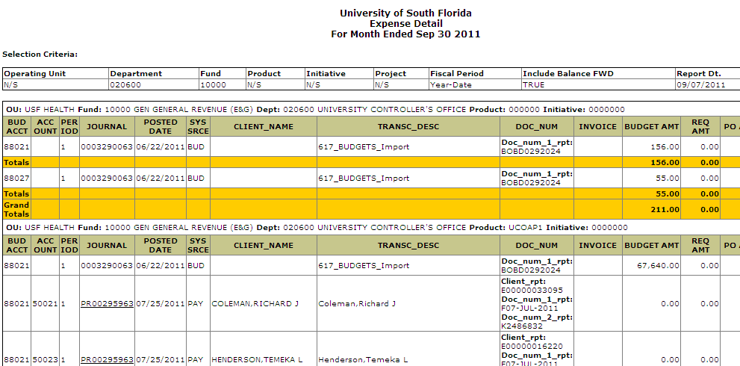

Sample Balance Sheet Summary page (for an open period)

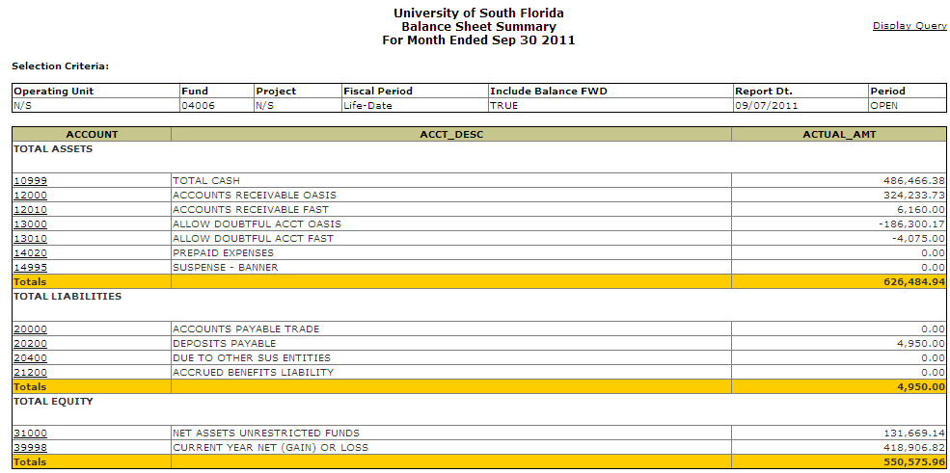

Sample Balance Sheet Detail Report page

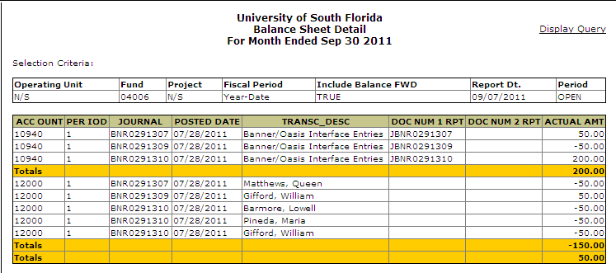

Sample Encumbrance Summary page

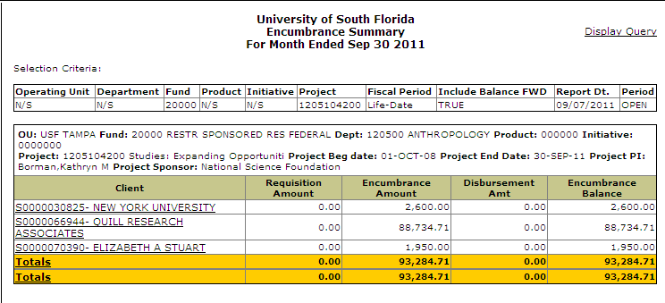

Sample Encumbrance Detail page

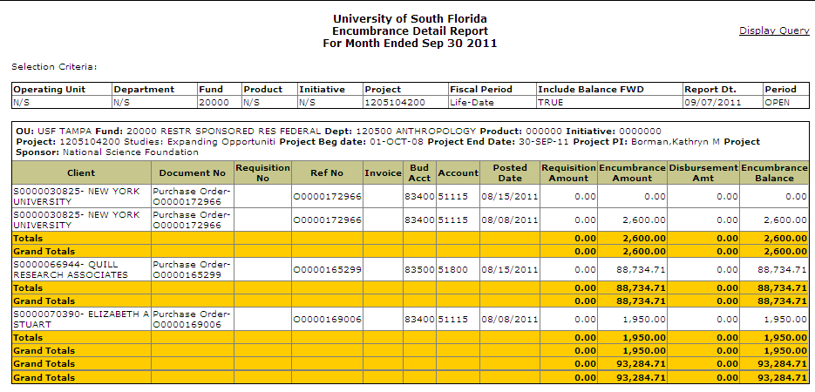

Help Contacts

For general comments or questions about the Finance Mart site or to present requests for enhancements, please contact us at financemart@usf.edu.

