Instructions for Electronic Submission of Non-payroll Expenditure Transfers (ETRs )

Content:

- Preparing an ETR request
- Submitting an ETR request
- Determining the status of the ETR request
- Searching the RNS system for the status of an ETR not yet entered into FAST!

- Preparing the ETR

The ETR form can be found at:

Journal Entry Template

The first tab is the SAMPLE form that includes the instructions for completing the form and the macros for uploading in FAST. The second tab contains the form and the third tab contains the justification form which also must be completed.

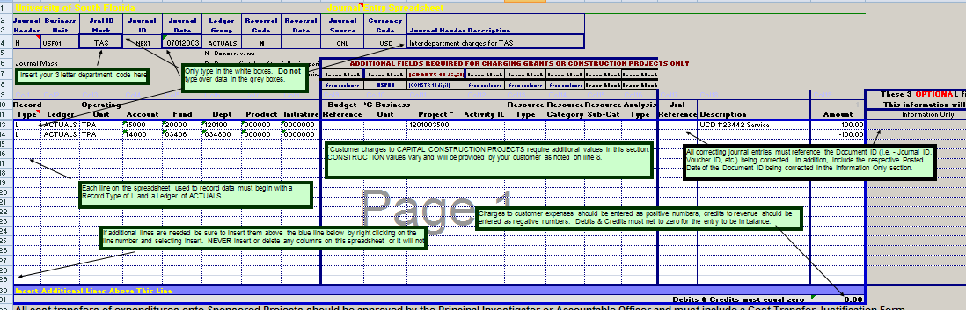

- Submitting an ETR

Prepare an email to submit the ETR request to rnsexpt@usf.edu as follows:

The subject line of the email must include (or will be returned) the fund source type for the FROM and TO transfer, any ProjectID(s) involved, and a brief description of the reason.

Examples:

ETR FROM 18300 TO 20000 [ProjectID] [Correctly classify subcontract payment)
ETR FROM 18300 TO 10000 [transfer supplies]

The email should include:

  - The appropriate subject line shown above
  - A properly completed ETR form attached
  - Sent directly from an authorized signatory (Accountable Officer, Accountable Officer Designee or Requisition Manager as listed in the FAST Workflow tables.)
  - include a scanned image of the original invoice
  - a copy of the ledger reflecting the posting of the original charge

Submit the email to rnsexpt@usf.edu .

All emails to the new address for ETR requests will create a unique incident.

Once an ETR is sent to the ETR email address listed above, the sender will receive an automated response. In the response, the ETR notification will include a Question Reference number. This email should be saved for tracking purposes.

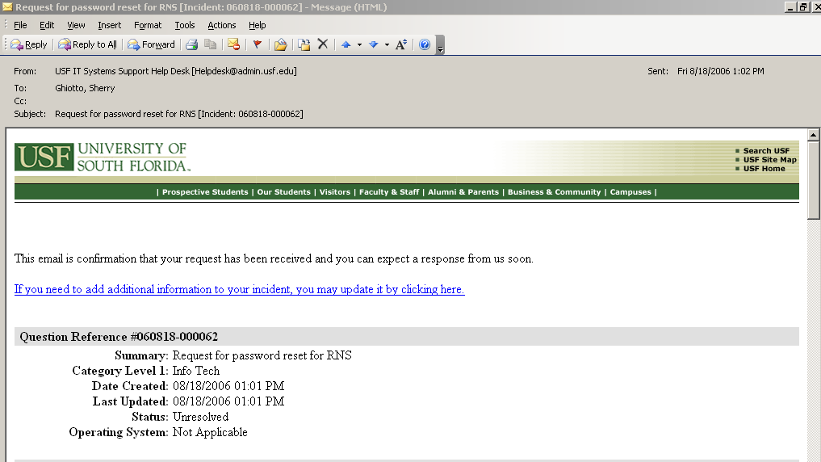

NOTE: If for any reason, you need to send additional information, the system allows you the ability to update an incident by clicking on the link provided in the email notification you received when originally submitting your request. Please do not reply to these automated emails as it will create a new incident and any comments or updates you have made will be on the new incident and not on your original request.

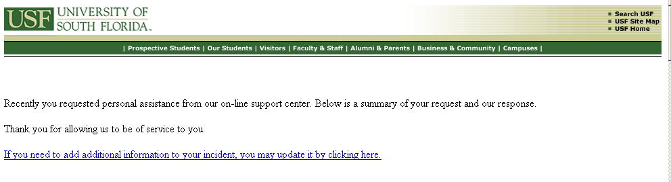

- Determining the status of the ETR

The RNS system (RNS) can be used to track the ETR from the time it is submitted and a Question Reference number assigned until it is entered into FAST or the request is denied.

The Question Reference number is needed to search the system to retrieve the current status if needed. However, each time an ETR is assigned to another staff member, approved, rejected, or entered into FAST!, a notification of the ETR status is sent to the original sender (contact) of the request.

States of status in RNS:
- Unresolved: The ETR is still in process. A notification email indicating that an ETR has been approved and forward for processing, could mean that it was either forwarded to be entered into FAST! or forwarded to another staff member for further review/approval.
- Solved: The ETR has either been denied or has been approved and entered into FAST! (A notification email from the RNS system should be received). Once it has been entered into FAST!, the posted transaction will appear on the ledger. The status of the incident request is then changed to “Solved”.
- Additional status values available in the system that may or may not be used include:
  - In Progress:
  - Project Tracking:
  - Updated:
  - Waiting for Customer:
  - Waiting for Review:
  - Waiting for Vendor:

- Searching the RNS system for the status of an ETR

Open Internet Explorer and go to the following link:

http://itsupportservices.custhelp.com

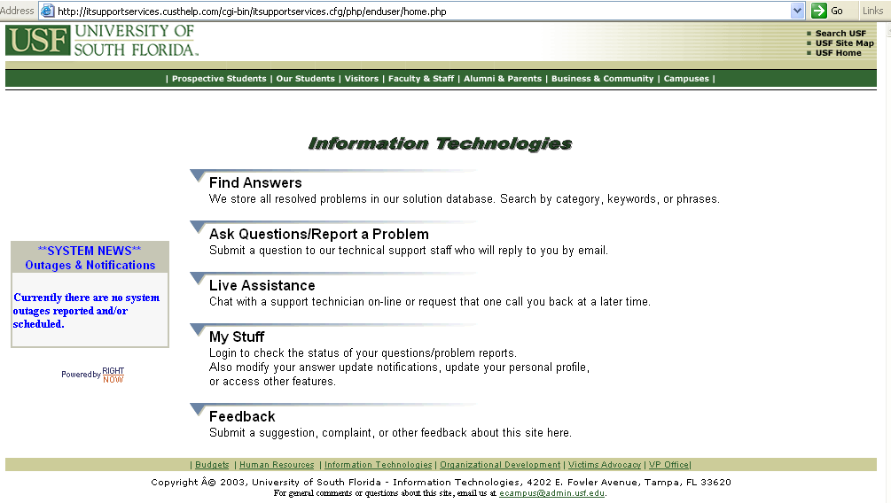

Click on the link to “My Stuff”. A new account may need to be created if you do not already have one.

To create a new account, click on Create a New Account and simply fill in the required fields and it will setup a new account. The password will be one that you specify when you create the account for yourself in the Right Now Service system.

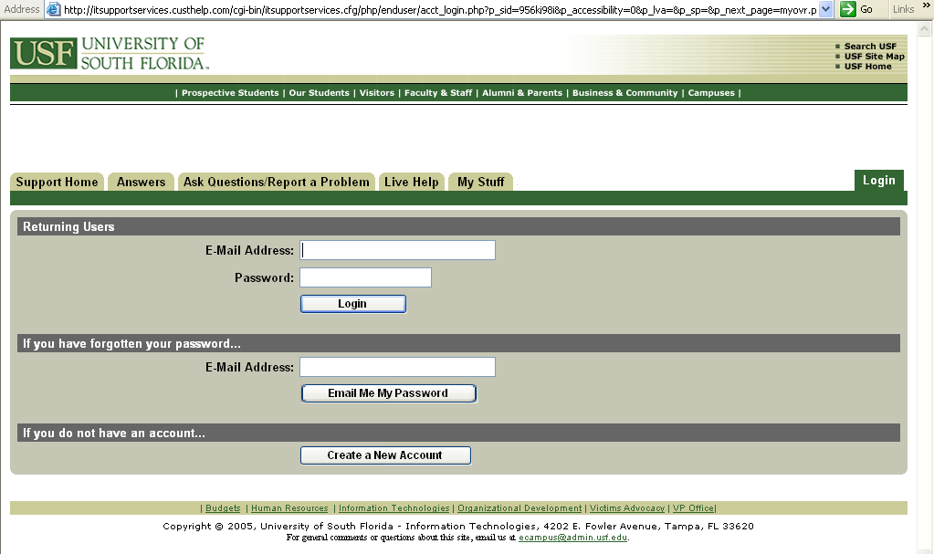
Once you are logged in, click on the link to “Questions”

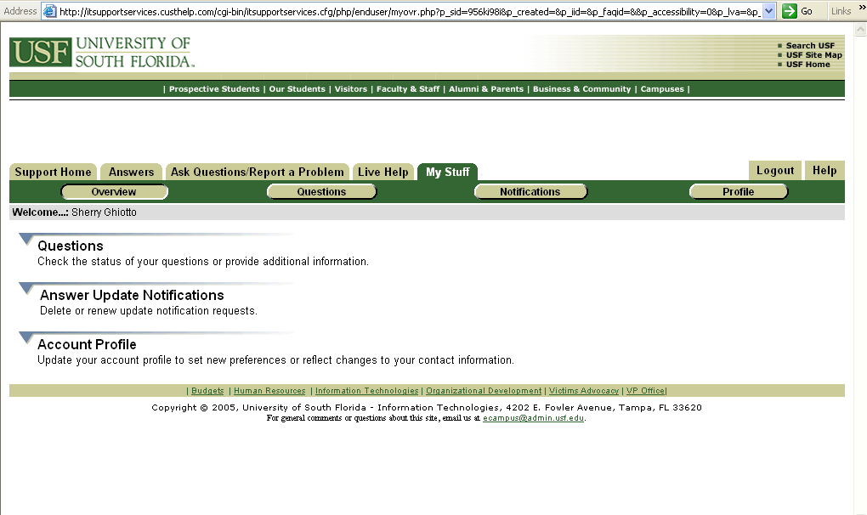

It will open up page with a list of your unresolved questions like this:

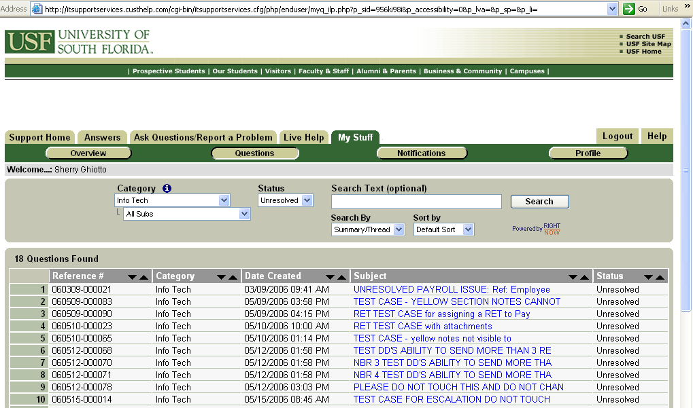

Once you are at the Questions page, change the “Search by” drop down box 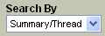 to select “Reference #”. 
Enter the Question Reference # in the Search Text box 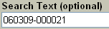 and click the
“Search” button.

The Question Reference record should return in the search results.

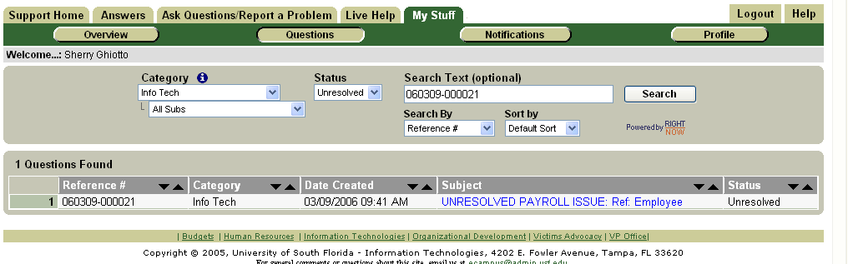
Click on the subject line of the record you wish to open/review. If your search returns no values found, you may need to change the status in the drop down box to a status other than Unresolved. You will be able to view the complete history and the current status.

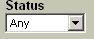

Contact information:

University Controller’s Office
Becky Merritt - 974-4750; bmerritt@usf.edu
Suzanne Roberts – 974-6050; robertss@usf.edu

General Accounting:
Tim Hamilton – 974-7686; thamilto@usf.edu
Antonio Alvarez – 974-4861; Antonio@usf.edu

Accounts Payable:
Richard Coleman – 974-2738; rcoleman@usf.edu
Mark Hamilton - -974-2305; mhamilto@usf.edu

Research Financial Management:
Doreen Shockley – 974-6921; dshockley@usf.edu
Chanda Haywood – 974-7009; chaywood@usf.edu

