

A FAST Refresher
How to lookup a voucher in Accounts Payable

(updated 09/21/2016)


Voucher Research in FAST

Practical Uses

Vendor may inquire about payment of an invoice
You may need to view the vendor invoice
You may need to view the accounting entries

Navigation:

Accounts Payable
Review Accounts Payable Info
Vouchers
Voucher

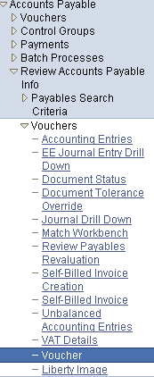

Then search with a Business Unit (USF01) and the voucher number (00337043 in the illustration below)

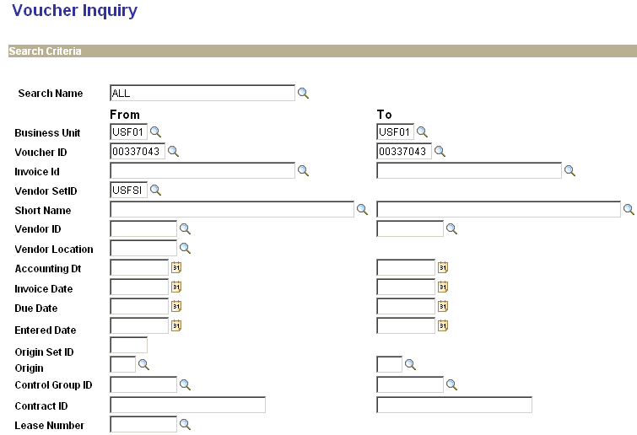
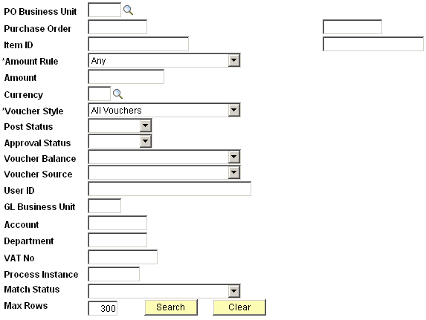

The search will reveal:

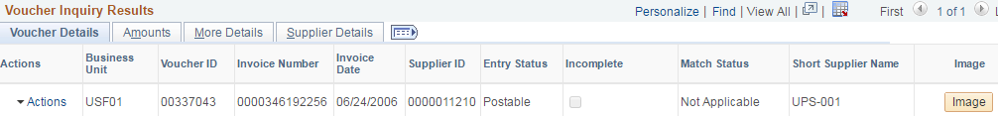

Click the “Actions” link to view accounting entries, payment information, voucher details, or the document status.

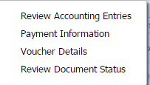 Select the desired item (for example accounting entries).

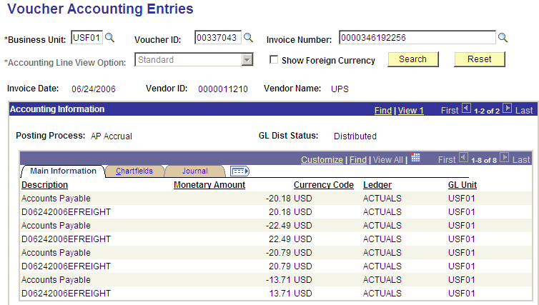

Or select payment information to view payment date, check number and amount.

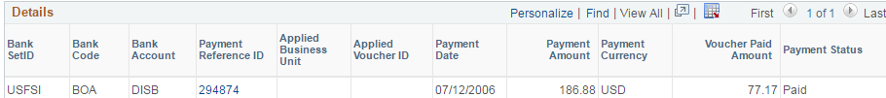

Click the image symbol to view an image of the vendor invoice (illustration below).

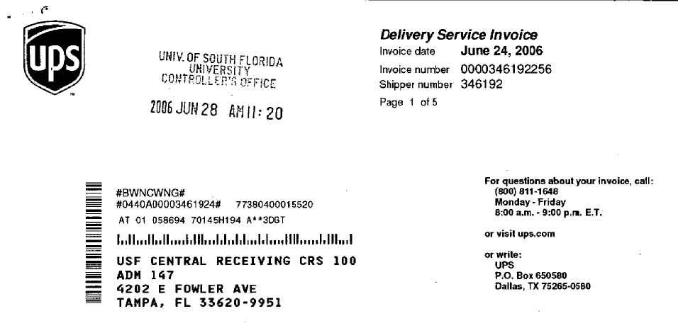

End of Document

